# Create a simple HTML document structure with a heading, a paragraph, and an image.

**Text Formatting: Apply bold and italic formatting to specific words within a paragraph.**

<!DOCTYPE html>

<html>

<head>

<tittle><h1> Simple HTML Document <h1></tittle>

</head>

<body>

<h2><b><i>What is HTML and CSS ?</i></b></h2>

<font size="4">

<p>

<b><i> HTML is a markup language used to define a structure of a web page. CSS is a style sheet language used to style the web pages by using different styling features. </i></b>, the code that is used to structure a web page and its content. For example, content could be structured within a set of paragraphs, a list of bulleted points, or using images and data tables.<b><i> the difference between HTML and CSS? </i></b>. Quite simply, HTML (Hypertext Markup Language) is used to create the actual content of the page, such as written text, and CSS (Cascade Styling Sheets) is responsible for the design or style of the website, including the layout, visual effects and background color.

</p>

</font>

<img src="https://i0.wp.com/pediaa.com/wp- content/uploads/2018/10/Difference-Between-HTML-and-CSS- Comparison-Summary.jpg?w=799&ssl=1">

</body>

</html>

# OUTPUT:

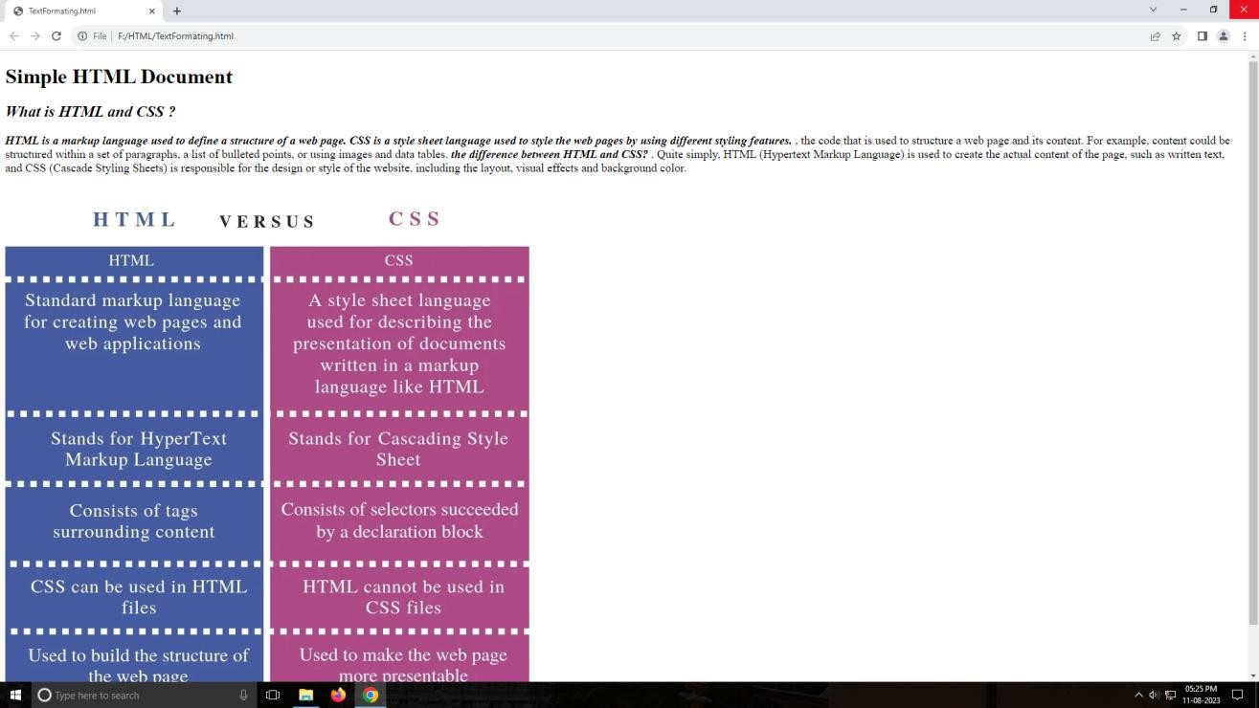

1. **Create an ordered (numbered) and an unordered (bulleted) list. Hyperlinks: Create a hyperlink that opens in a new tab.**

<!DOCTYPE html>

<html lang="en">

<head>

<meta charset="UTF-8">

<meta name="viewport" content="width=device-width, initial-scale=1.0">

<title>Lists and Hyperlink Example</title>

</head>

<body bgcolor="pink">

<meta charset="UTF-8">

<meta name="viewport" content="width=device-width, initial-scale=1.0">

<title>Lists and Hyperlink Example</title>

</head>

<body>

<h1>List Examples</h1>

<h2>Ordered List:</h2>

<ol>

<li><a href="https://[www.javatpoint.com/hibernate-tutorial](http://www.javatpoint.com/hibernate-tutorial)">First Item</a>

</li>

<li>second Item</li>

<li>Third Item</li>

</ol>

<h2>Unordered List:</h2>

<ul>

<li><a href="https://[www.javatpoint.com/hibernate-tutorial](http://www.javatpoint.com/hibernate-tutorial)">Blue</a>

</li>

<li>Green</li>

<li>Pink</li>

</ul>

<h2>Hyperlink:</h2>

<p>Visit <a href="https://[www.example.com](http://www.example.com/)" target="_blank" rel="noopener noreferrer">Example Website</a> to learn more.</p>

</body>

</html>

# OUTPUT:

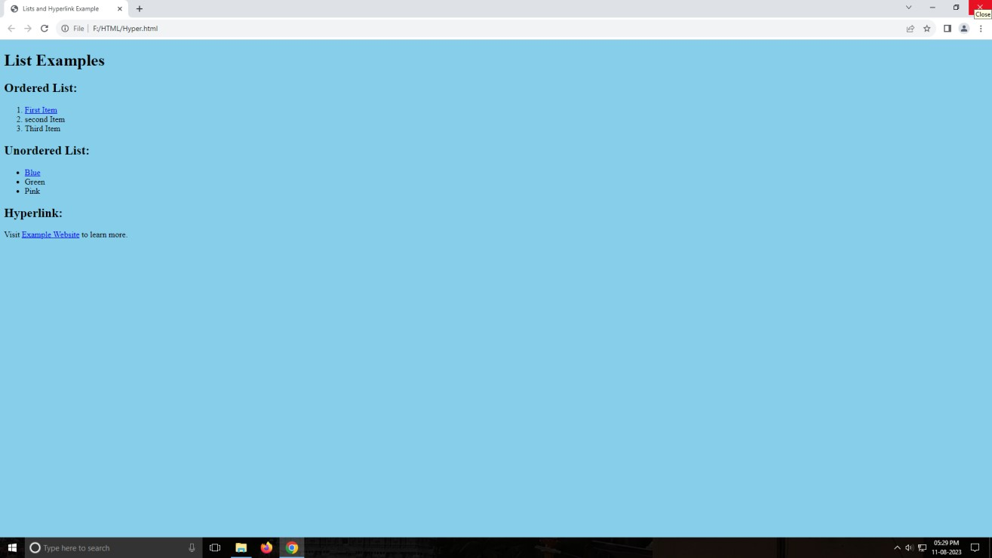

1. **Insert an image and provide appropriate alt text. Style the image with CSS to control its size.**

<!DOCTYPE html>

<html lang="en">

<head>

<meta charset="UTF-8">

<meta name="viewport" content="width=device-width, initial-scale=1.0">

<title>Image and CSS Styling</title>

<style>

/* CSS rules to style the image */

.styled-image {

width: 300px; /* Set the desired width */ height: 100; /* Maintain aspect ratio */ border: 2px solid #333;

box-shadow: 4px 4px 8px rgba(0, 0, 0, 0.2);

}

</style>

</head>

<body bgcolor="pink"><center>

<h1>Images of Guitar and violin</h1>

<!-- Inserting an image with alt text and applying CSS class -->

<img class="styled-image" src="IMG_20230501_WA0001 (15).jpg" alt="A beautiful img ">

<img class="styled-image" src="IMG_20230501_WA0001 (18).jpg" alt="A beautiful img ">

<img class="styled-image" src="IMG_20230501_WA0001 (16).jpg" alt="A beautiful img">

<p>Appearing beautiful images.</p>

</body>

</html>

# OUTPUT:

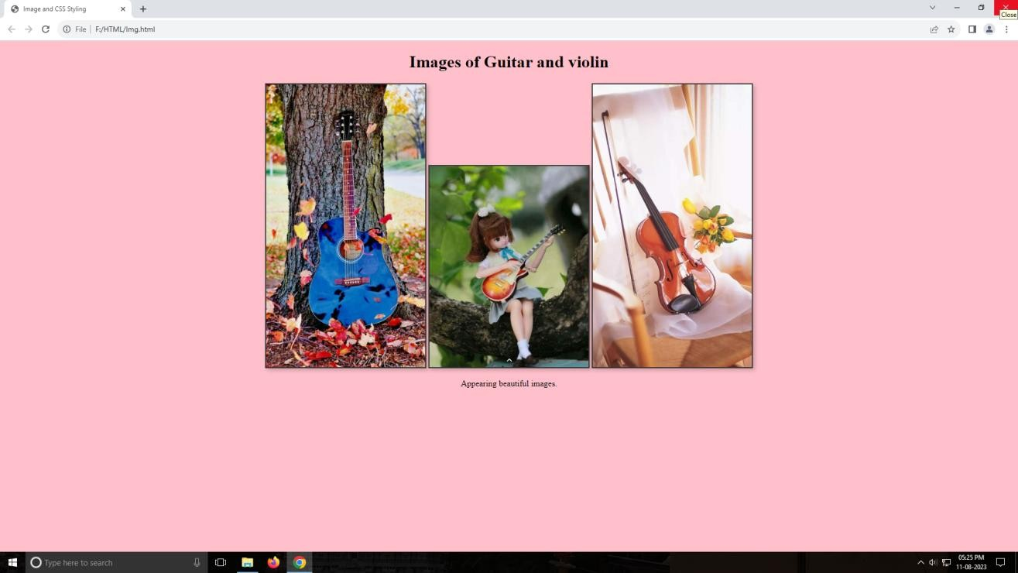

1. **Explain the CSS box model and its components (margin, border, padding, content).**

# Adjust the width, height, margin, padding, and border of an element.

The CSS box model is a fundamental concept in web design that describes how elements on a webpage are structured and how their dimensions and spacing are calculated. It consists of four main components: content, padding, border, and margin. Each of these components contributes to the overall size and spacing of an element.

1. **Content:** The content area is where the actual content of an element, such as text or images, is displayed. It's the innermost part of the element and is affected by properties like width and height.
2. **Padding:** Padding is the space between the content and the element's border. It provides breathing room around the content. Padding can be set using properties like padding-top, padding-right, padding-bottom, and padding-left.
3. **Border:** The border is the line or area that surrounds the content and padding. It separates the content from the padding and margin. Borders can have different styles, widths, and colors. Border properties include border- width, border-style, and border-color.
4. **Margin:** Margin is the space outside the element's border. It creates a gap between the element and other nearby elements. Margin properties, such as margin-top, margin-right, margin-bottom, and margin-left, control these spaces.

**Adjusting the Box Model Components:**You can adjust the width, height, margin, padding, and border of an element using CSS properties.

**Example:** Let's say you have an element with the class box and you want to set its dimensions, margin, padding, and border.

.box {

width: 200px; /* Width of the content area */ height: 150px; /* Height of the content area */

margin: 20px; /* Margin around the entire element */ padding: 10px; /* Padding around the content area */

border: 2px solid red; /* Border around the content and padding */

}

In this example, the total width of the element including content, padding, border, and margin would be:

Total width = content width + 2 * (border width) + 2 * (padding width) + 2

* (margin width)

Total height = content height + 2 * (border width) + 2 * (padding width) + 2

* (margin width)

Remember that borders and padding add to the dimensions of the element, while margins create space around the element.<!DOCTYPE html>

<html>

<head>

<style>

.styled-paragraph { margin-left: 100px; margin-top: 20px; border-style: double; padding: 10px; border-color:Blue;

}

</style>

</head>

<body>

<p class="styled-paragraph">What is html and css</p>

<p class="styled-paragraph">what is object oriented programming language</p>

<p class="styled-paragraph">what is hibernate</p>

</body>

</html>

# OUTPUT:

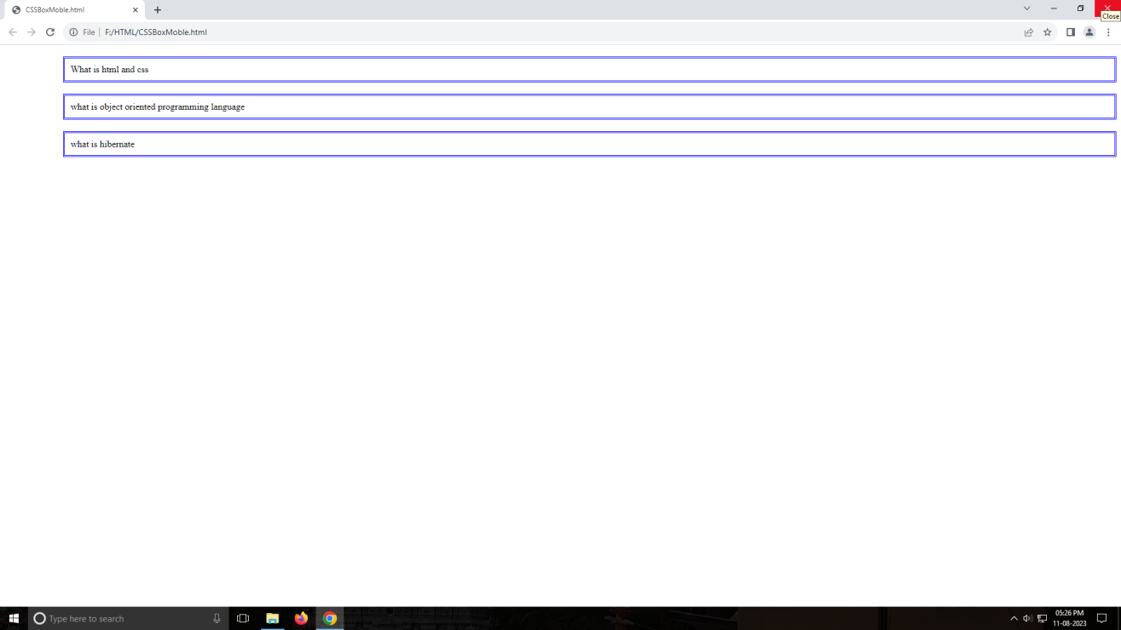

1. **Create a simple form with text fields, radio buttons, checkboxes, and a submit button. Apply CSS styles to improve the form's appearance.**

<!DOCTYPE html>

<html>

<head>

</head>

<body>

<div >

<h2>Simple Form</h2>

<form>

Full Name: <input style="border-color:skyblue"; type="text" id="name" name="name" placeholder="Your name" required>

<br> <br>

Email: <input style="border-color:Red"; type="email" id="email" name="email" placeholder="Your email" required>

<br> <br>

<br> <b> Gender </b> <br>

<input type="radio" value="Male" name ="gender" checked > Male <br>

<input type="radio" value="FeMale" name ="gender" checked > FeMale

<br>

<br></br>

Mobile number: <input style="border-color:green"; type="mobile" id="mobile" name="mobile" placeholder="numbers" required>

<br> <br> Hobbies:</label>

<input type="checkbox" id="reading" name="hobbies" value="reading">

<label for="reading">Reading</label>

<input type="checkbox" id="traveling" name="hobbies" value="traveling">

<label for="traveling">Traveling

<input type="checkbox" id="Playing games" name="hobbies" value="Playing Games">

<label for="Playing Games">Playing Games

<input type="checkbox" id="Learn New Things" name="hobbies" value="Learn New Things">

<label for="Lean New Things">Learn New Things

<br> <br>

<button style="background-color:Pink; border-color:blue"; type="submit" id="test" align="80pt">Submit</button>

</form>

</div>

</body>

</html>

</body>

</html>

# OUTPUT:

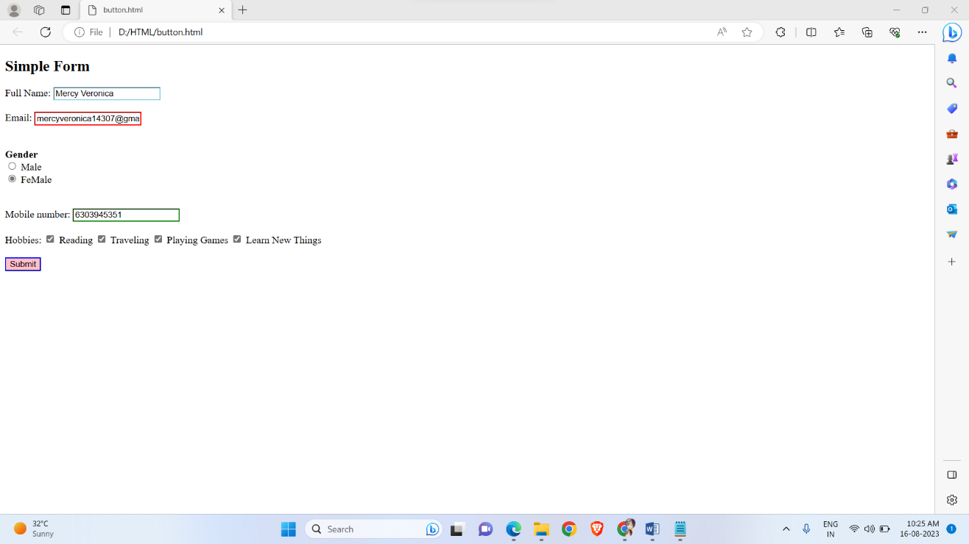

1. **How do you link an external CSS style sheet to an HTML document?**

To link an external CSS style sheet to an HTML document, you use the element within the Here's the basic syntax:

# Section of your HTML code.

<!DOCTYPE html>

<html>

<head>

<link rel=”stylesheet” type=”text/css” href=”path/to/your/stylesheet.css”>

</head>

<body>

<!--your HTML content goes here -->

</body>

</html>

Let's break down the parts:

* <!DOCTYPE html>: This declaration specifies that you're using HTML5.
* <html>: The root element of your HTML document.
* <head>: The section where you include metadata about your document, including the CSS stylesheet.
* <link>: The element used to link an external resource, in this case, your CSS stylesheet.
* rel="stylesheet": Specifies that the linked resource is a stylesheet.
* type="text/css": Indicates the type of the linked resource (CSS). 7.href="path/to/your/stylesheet.css": This is where you provide the path to your external CSS file. Replace path/to/your/stylesheet.css with the actual path to your CSS file. 8.<body>: The section where you place the visible content of your HTML document.
* Remember to replace with theactual relative or absolute path to your CSS file. This path should be based on the location of your HTML file.

# Here's an example with a more specific path:

<!DOCTYPE html>

<html>

<head>

<link rel=”stylesheet” type=”text/css” href=”styles/mystyles.css”>

</head>

<body>

<!--your HTML content goes here -->

</body>

</html>

# What is the purpose of the style attribute in HTML tags?

The style attribute in HTML tags is used to apply inline CSS styles directly to individual HTML elements. Unlike external or internal CSS stylesheets that apply styles to multiple elements across a document, inline styles affect only the specific element they are applied to.

The style attribute consists of one or more CSS property-value pairs, where each property defines a particular styling aspect (such as color, font-size, margin, etc.), and the corresponding value specifies how that aspect should be styled. Here's an example:

<p style="color: blue; font-size: 16px;">This is a blue and larger text.</p>

In this example, the style attribute is applied directly to the <p> (paragraph) element. The styles defined within the attribute will only affect this specific paragraph element.

# Here are some key points to consider about using the style attribute:

1. **Inline Styling :** The style attribute is an inline styling method, meaning the styles are applied directly to the specific HTML element. This can be useful for quick and specific styling changes.
2. **Specificity:** Styles applied using the style attribute have high specificity. This means they will override conflicting from external style sheets or styles defined in <style> blocks within the HTML document.
3. **Limited Reusability:** Inline styles are not reusable across multiple elements. If you want styling across multiple elements orpages, using external stylesheets is more efficient.
4. **Maintenaces:** Inline styles can make the HTML code harder to maintain, especially when you have a lot of elements with individual styles. External stylesheets provide a cleaner separation of content andpresentation.
5. **Override:** If you later decide to change the styling of your elements,you would need to modify the style attributes individually, which could become cumbersome.

While the style attribute is handy for quick adjustments or applying unique styles to specific elements, for larger projects, it's generally recommended to use external CSS style sheets for better organization, maintainability, and reusability of your styles.